Praktikum 3 – Data Analitik  
**GRAFIK SPASIAL**

Dalam praktikum ini akan dipelajari dan dipraktekkan bagaimana melakukan visualisasi data spasial menggunakan beberapa library seperti ggplot2, maps dan ggmap.

**Notes :**

|  |
| --- |
| > library(caret)  > library(dplyr)  > library(ggmap)  >  > data(Sacramento)  > df_sacramento <- Sacramento %>% group_by(city) %>%  + summarize(median_price = median(price), transactions = n(),  + latitude = mean(latitude), longitude = mean(longitude))  >  > ggplot() +  + geom_point(data = df_sacramento, mapping = aes(x = longitude, y = latitude,  + col = median_price, size = transactions)) +  + scale_color_distiller(palette = "YlOrRd", direction = 1) |

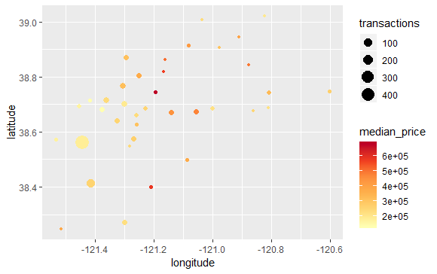

|  |
| --- |
| > ggplot(data = df_sacramento, mapping = aes(x = longitude, y = latitude)) +  geom_point(aes(col = median_price, size = transactions)) +  geom_text(aes(label = city), size = 2, nudge_y = 0.01) +  scale_color_distiller(palette = "YlOrRd", direction = 1) |

|  |
| --- |
| > height <- max(Sacramento$latitude) - min(Sacramento$latitude)  > width <- max(Sacramento$longitude) - min(Sacramento$longitude)  > sac_borders <- c(bottom = min(Sacramento$latitude) - 0.1 * height,  + top = max(Sacramento$latitude) + 0.1 * height,  + left = min(Sacramento$longitude) - 0.1 * width,  + right = max(Sacramento$longitude) + 0.1 * width)  >  > map <- get_stamenmap(sac_borders, zoom = 5, maptype = "toner-lite")  Map tiles by Stamen Design, under CC BY 3.0. Data by OpenStreetMap, under ODbL.  > ggmap(map) |

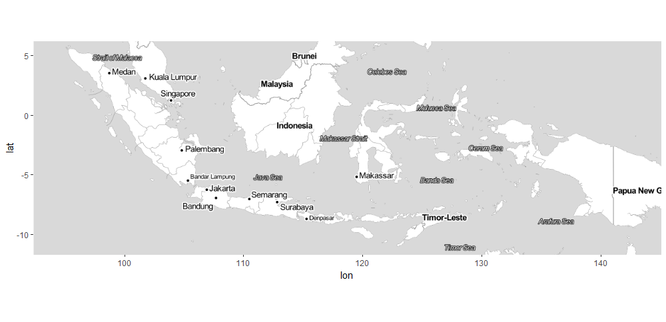

Latihan : Plot data yang menggambarkan situasi harga daging sapi di berbagai provinsi di Indonesia

|  |  |  |
| --- | --- | --- |
| > library(ggplot2)  > library(ggmap)  > library(maps)   |  | | --- | | > data(data_daging_sapi)  Warning message:  In data(data_daging_sapi) : data set ‘data_daging_sapi’ not found  > df <- data_daging_sapi %>% group_by(Provinsi) %>%  + summarize(median_price = median(Harga.Daging.Sapi), transactions = n(),  + Latitude = mean(Latitude), Longitude = mean(Longitude))  Warning message:  package ‘bindrcpp’ was built under R version 3.4.4  > ggplot() +  + geom_point(data = df, mapping = aes(x = Longitude, y = Latitude,  + col = median_price, size = transactions)) +  + scale_color_distiller(palette = "YlOrRd", direction = 1)    > ggplot(data = df, mapping = aes(x = Longitude, y = Latitude)) +  + geom_point(aes(col = median_price, size = transactions)) +  + geom_text(aes(label = Provinsi), size = 2, nudge_y = 0.01) +  + scale_color_distiller(palette = "YlOrRd", direction = 1) | |  |   > height <- max(data_daging_sapi$Latitude) - min(data_daging_sapi$Latitude)  > width <- max(data_daging_sapi$Longitude) - min(data_daging_sapi$Longitude)  > sac_borders <- c(bottom = min(data_daging_sapi$Latitude) - 0.1 * height,  + top = max(data_daging_sapi$Latitude) + 0.1 * height,  + left = min(data_daging_sapi$Longitude) - 0.1 * width,  + right = max(data_daging_sapi$Longitude) + 0.1 * width)  >  > map <- get_stamenmap(sac_borders, zoom = 5, maptype = "toner-lite")  Map tiles by Stamen Design, under CC BY 3.0. Data by OpenStreetMap, under ODbL.  > ggmap(map) |

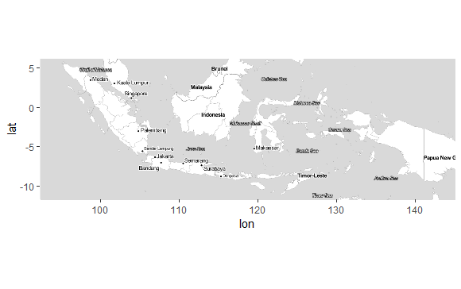

|  |
| --- |
| > ggmap(map) +  + geom_point(data = df, mapping = aes(x = Longitude, y = Latitude,  + col = median_price, size = transactions)) +  + scale_color_distiller(palette = "YlOrRd", direction = 1) |

**Tugas 3 :**

Gunakan data salah satu komoditas pangan lainnya yang bersumber dari situs hargapangan.id serta lakukan visualisasi dan analisis situasi harga di berbagai provinsi. Data setiap praktikan tidak boleh sama.

**Data beras kualitas medium 1**

|  |  |  |  |  |
| --- | --- | --- | --- | --- |
| |  | | --- | | > beras_medium=read.delim("clipboard")  Warning messages:  1: package ‘RMySQL’ was built under R version 3.4.4  2: package ‘DBI’ was built under R version 3.4.4  3: package ‘arules’ was built under R version 3.4.4  4: package ‘Matrix’ was built under R version 3.4.4  > library(caret)  Loading required package: lattice  Loading required package: ggplot2  Warning messages:  1: package ‘caret’ was built under R version 3.4.4  2: package ‘ggplot2’ was built under R version 3.4.4  3: In as.POSIXlt.POSIXct(Sys.time()) :  unable to identify current timezone 'A':  please set environment variable 'TZ'  > library(dplyr)  Attaching package: ‘dplyr’  The following objects are masked from ‘package:arules’:  intersect, recode, setdiff, setequal, union  The following objects are masked from ‘package:stats’:  filter, lag  The following objects are masked from ‘package:base’:  intersect, setdiff, setequal, union  Warning message:  package ‘dplyr’ was built under R version 3.4.4  > library(ggmap)  Google's Terms of Service: https://cloud.google.com/maps-platform/terms/.  Please cite ggmap if you use it! See citation("ggmap") for details. | |  | | |  | | --- | | > data(beras_medium)  > df <- beras_medium %>% group_by(Provinsi) %>%  summarize(median_price = median(Harga.Beras.Medium1), transactions = n(),  Latitude = mean(Latitude), Longitude = mean(Longitude))  > ggplot() +  + geom_point(data = df, mapping = aes(x = Longitude, y = Latitude,  + col = median_price, size = transactions)) +  + scale_color_distiller(palette = "YlOrRd", direction = 1)    > ggplot(data = df, mapping = aes(x = Longitude, y = Latitude)) +  geom_point(aes(col = median_price, size = transactions)) +  geom_text(aes(label = Provinsi), size = 2, nudge_y = 0.01) +  scale_color_distiller(palette = "YlOrRd", direction = 1)    > height <- max(beras_medium$Latitude) - min(beras_medium$Latitude)  > width <- max(beras_medium$Longitude) - min(beras_medium$Longitude)  > sac_borders <- c(bottom = min(beras_medium$Latitude) - 0.1 * height,  top = max(beras_medium$Latitude) + 0.1 * height,  left = min(beras_medium$Longitude) - 0.1 * width,  right = max(beras_medium$Longitude) + 0.1 * width)  > map <- get_stamenmap(sac_borders, zoom = 5, maptype = "toner-lite")  > ggmap(map)    > ggmap(map) +  geom_point(data = df, mapping = aes(x = Longitude, y = Latitude,  col = median_price, size = transactions)) +  scale_color_distiller(palette = "YlOrRd", direction = 1) | | |